9 клас
07.04.2020
Урок – подорож
Тема : Велика Британія сьогодні.
Мета :
- розвивати навички аудіювання , читання ;
- навчати використовувати лексичний та тематичний матеріал у спілкуванні;
- розвивати світогляд ;
- виховувати позитивне ставлення до культури Великої Британії .
.

Хід уроку.
І. Вступна частина .
Good morning ! Very glad to see you ! Today we are going to travel to Great Britain . It’s a very interesting and unusual country . Our guides will tell you about all parts of this kingdom , about the capital and people of Great Britain
So , the subject of our travelling is “Great Britain”.Тема уроку: «Велика Британія сьогодні» The country is washed by the Atlantic Ocean , the North Sea and the Irish Sea , which between Great Britain and Ireland .
Thousands of years ago , the mainland of Europe stretched much further west than now , and by the sinking 490 of the land , the ocean covered a great deal of the continent . The British Isles and the neighbouring small islands were left above the surface of the sea , because they were the highest parts of the land . The water flowed into the valleys among the hills , thus producing an uneven coast and many good harbours .
The first thing that people see when they cross the English Channel is the chalk cliffs near Dover. That is why the Romans called this country Albion ( from the Latin word which means “white”.) It is a sort of symbol of England .
The highest mountains are in the central and northern parts of Scotland , in Wales and in the north – west of England , but they are by no means high as we understand high mountains . The mountains of the British Isles are much the same height as those of the Crimea . In North – west England , there are many beautiful lakes . This is called the “Lake District”. It is one of the most beautiful places on the British Isles .

Pupils,you should read about the flag attentively(уважно)
The flag of great Britain has three crosses – St. George’s Cross from , the flag of England , St. Andrew’s Cross , from the flag of Scotland , St. Patrick’s Cross , from the flag of Ireland .
It got the name of Union Jack from James I under whome Scotland and England were united in the 17th century .
So , historically , the territory of the United Kingdom is divided into four parts : Scotland , England , Wales and Northern Ireland . Let’s start our travelling . Our guides will tell you about all these countries .
At first , welcome to England !
Guide 1 :
I’m from England . I want you to listen to my story about this part of the UK .
Teacher : Before speaking about Scotland I want you to listen to the poem “ My Heart’s in the Highlands ” by Robert Burns .
Guide 1 :
My Heart’s in the Highlands.
My heart’s in the Highlands, my heart is not here;
My heart’s in the Highlands, a chasing the deer;
A chasing the wild deer, and following the roe -
My heart’s in the Highlands wherever I go.
Farewell to the Highlands, farewell to the North,
The birthplace of valour, the country of worth:
Wherever I wander, wherever I rove,
The hills of the Highlands for ever I love.
Farewell to the mountains high covered with snow;
Farewell to the straths and green valleys below;
Farewell to the forests and wild-handing woods;
Farewell to the torrents and loud pouring floods.
My heart's in the Highlands, my heart is not here;
My heart's in the Highlands, a chasing the deer;
A chasing the wild deer, and following the roe -
My heart’s in the Highlands wherever I go
(вірш вивчити напам,ять бажаючим)
Guide 1:
The Geographical Position of Great Britain
The United Kingdom of Great Britain and Northern Ireland is a part of a group of islands to the north-western coast of Europe . Great Britain is not large . It takes just 6 hours to travel in a fast train from London , the capital of London to Edinburgh , the capital of Scotland . Great Britain also lies not far from the continent . It is separated from the continent by the North Sea and the English Channel . The Channel in its narrowest part ( the Strait of Dover ) is only 32 km wide and when the weather is fine one can easily see from the middle of the Channel the French coast . Great Britain has a very good geographical position as it lies on the crossways of the sea routes from Europe to other parts of the world . The main sea route from Europe to America also passes through the Channel . The sea connects Britain with Belgium , Holland , Denmark , Norway . There are no big rivers in Great Britain . The largest river is the Thames . London , the capital of Great Britain , is on the Thames .

Guide 2:
The United Kingdom
To the west of the continent of Europe lie two large islands called the British Isles . The larger of these is known as Great Britain , the smaller , Ireland . The North Sea and the English Channel separate the British Isles from the European continent . The larger island of Great Britain consists of three parts : England , Scotland and Wales which were once separate kingdoms . After centuries of war at the beginning of the 18th century England , Scotland and Wales were united . In 1800 Ireland was included in the United Kingdom of Great Britain and Northern Ireland . The Irish , however , continued to struggle for self-government and in 1922 twenty - two 0f the thirty - two Irish counties formed the independent Irish Republic , now called Eire , with the capital in Dublin . Six northern counties remained a part of the UK , and since that time the official name of the state has become the United Kingdom of Great Britain and Northern Ireland .

Scotland
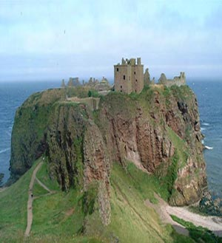
Guide 2 :
Scotland lies to the north of England . People who live in Scotland are Scots . The capital of Scotland is Edinburgh . Edinburgh is not the largest city in Scotland . Glasgow which has population of over one million , is twice as large as Edinburgh . Edinburgh has no large factories . Publishing is its well-known industry . Edinburgh is a beautiful city . The first thing you see in Edinburgh is the Rock . It is in the middle of the city . The Edinburgh castle stands on this hill . The Castle looks like a castle from a fairy tail , and parts of it are more than a thousand years old . From the top of the Castle there is a beautiful view of the hill and the sea .
Scots built fortress – like castles in the Highlands to keep off the enemy . Their territory was divided by the clans ( or tribes ) to which they belonged . The clans were social groups of common ancestors, in other words , they were related to each other and had same surnames . The head of the clan had a distinct title by using the definite article before his name like the Mac – Greggors or the clan Mac – Greggor . Scottish surnames that begin with Mac mean the descendant of and not as many people think , son of . Therefore MacDonalds belong to the tribe of MacDonalds as long as the father is a MacDonald , the wife can be of another clan .
The Stuart clan was famous for their Queen – Mary Stuart , Queen of Scots ( 1560 – 1567 ) who was beheaded by Elizabeth I , queen of England ( 1533 – 1603 ) , in 1567 . Later her son James I became king of Great Britain ( 1603 – 1625 ) . It was only in 1747 that the clan chiefs in . Scotland lost their distinctive powers .
So , let’s continue our travelling in Wales .
Wales and Welsh
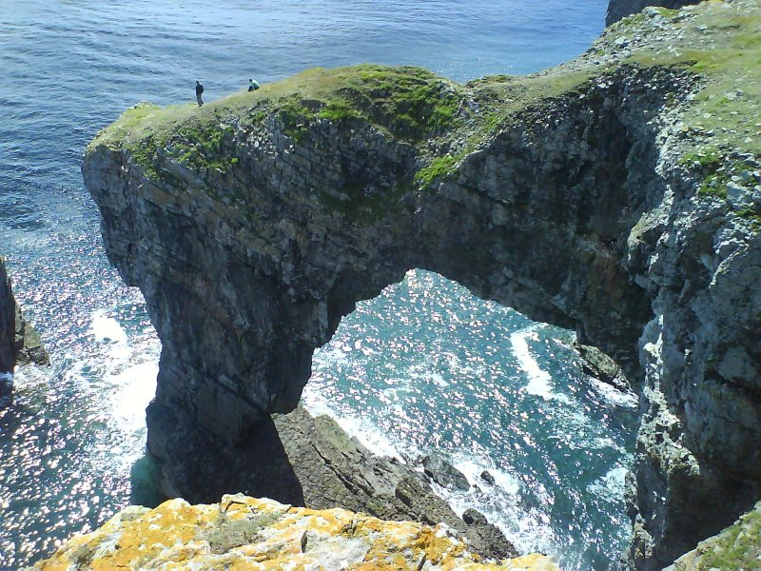
Wales is a lovely country with great mountains , some of them beautiful and green and wooded , others bare and wild . There are gentle , fertile valleys with little farmhouses or cottages sheltering on the slopes of the mountains . Snowdon , the highest mountain in England and Wales is dark and wildlooking . The Welsh are natives of the British Isles , the only nation that has preserved its original language – Welsh , that is one of the Celtic tribes . They lived on their territory long before the Roman invasion . They fought the Anglo – Saxons and won great victories over them under the leadership of King Arthur . No one has a deeper love of his home and family than the Welshman . King Arthur was a semilegendary figure who fought the Saxon invaders and won a great battle at Mount Badon . These old stories tell us of Arthur’s miraculous coming , of how he became King and established the famous order of the Round Table . The round table was to show that no knight , not even the King himself , was “ head of the table ”; all were equal and the King was just “ first among equals ” . The Welsh are a nation of singers .
Welcome to Northern Ireland !

Northern Ireland, also known as Ulster, is still a part of the United Kingdom. It is made up of six countries: Antrim, Armagh, Down, Fermanagh, Londonderry, Tyrone. One third of the population lives in and around the capital, Belfast. Belfast is also the most important port and commercial and industrial centre. Some parts of the territory, those that are not close to the capital, have remained mainly rural.
The Irish population is divided into two groups: the Protestants and the Catholics. The Protestants are of British origin. They are descendants of British settlers who came to Ireland in the XVI-th and XVII-th centuries, during and after the Reformation. The Catholics are mostly natives of Ireland.
The Protestants were the majority and dominated the Catholics with strong discrimination. In 1968 the Catholics began the movement for equal civil rights. The fightings between the two groups of the population continue to this day.
Northern Ireland has a strong cultural tradition: songs, dances, literature and festivals. It has its own Art Council, and there are orchestras, theatres, ballet and opera companies.

We’ve traveled across Great Britain . I hope that you have got new knowledge about this country . And now , as a conclusion , I want you to do this quiz .(ще раз уважно перечитайте інформацію про Обєднане королівство і виконайте наступні завдання)
I.
- Where is Great Britain situated ?
- What countries does the UK consists of ?
- Where is England situated ?
- What towns of England do you know ?
- Where is Scotland situated ?
- What is the capital of Scotland ?
- What famous places of London do you know?
- What holidays are celebrated in Great Britain?
- What can you say about Royal Family ?
II.
Well, I think that you were really working hard at the lesson . We have learned many facts about this country . And if you were attentive , it would be easy for you to pass the test . Open your exercise – books and write down the word “ Test”. It will be a multiple choice test . Choose ‘a’ , ‘b’ or ‘c’ . (5 min )
- The United Kingdom consists of four different countries …
  - England , Scotland , Wales and Ireland .
  - England , Scotland , Wales and Northern Ireland .
  - Britain , Scotland , Wales and Northern Ireland .
- Great Britain is separated from the continent by …
  - the English Channel .
  - the North Channel .
  - the Irish Sea .
- The highest peak in Great Britain is …
  - Ben Nevis .
  - Snowdon .
  - Loch Ness .
- The longest rivers in the UK are …
  - the Trent and the Tweed .
  - the Wye and the Strait of Dover .
  - the Severn and the Thames .
- The British Isles are surrounded by the shallow waters of …
  - the Irish Sea and the North Sea , the North Channel and the Indian Ocean .
  - the Irish Sea and the Black Sea , the North Channel and the Atlantic Ocean .
  - the Irish Sea and the North Sea , the North Channel and the Atlantic Ocean .
- The population of the UK is …
  - 48 mln people .
  - 56 mln people .
  - 244 mln people .
Thank you for your work. Good bye.

