2-3 клас Англійська мова

<https://meet.google.com/ziv-yjjv-myp>

1. клас

**Тема уроку** «Що вдягає Люк?»

1. виконати завдання

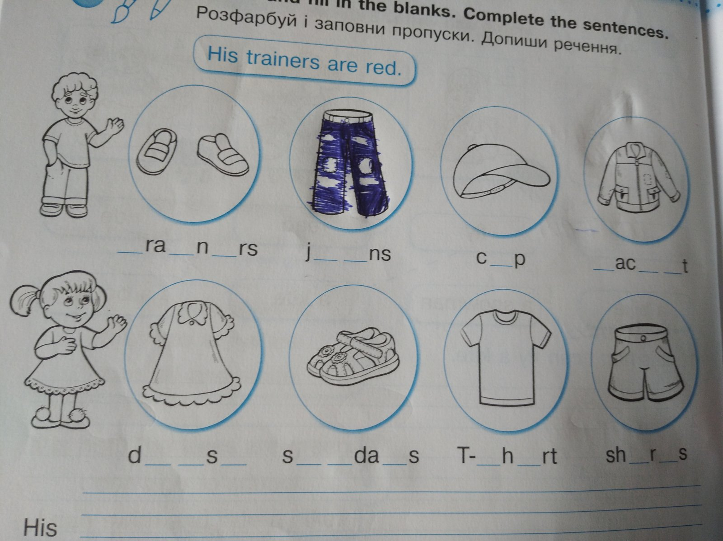

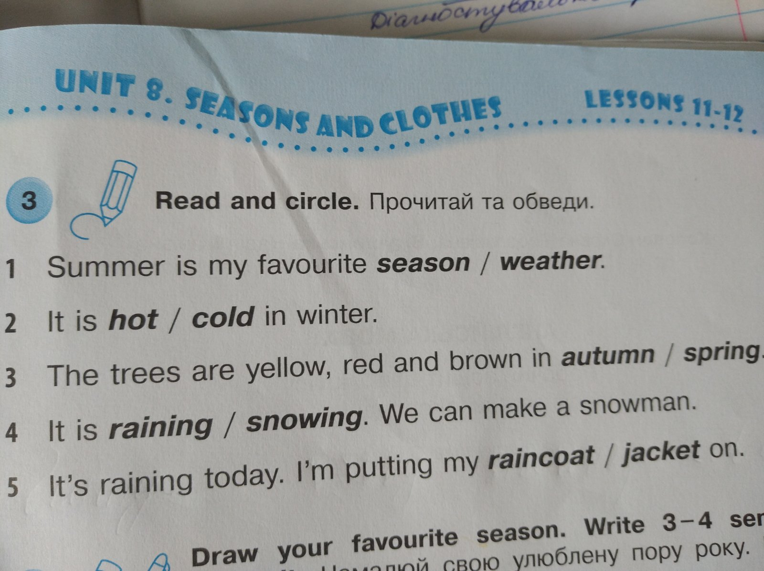

3 клас

**Тема уроку** «Контроль аудіювання»

***I. True or false. Визначити чи правдиві речення. + чи -***

1. Easter is in summer.

2. We can see many beautiful yellow daffodils in spring.

3. Easter starts on Friday in Britain.

4. People give children wood eggs for Easter.

5. Children can eat eggs on Easter Sunday.

6. In Ukraine people make Easter cakes and paint eggs.

***II. Choose the correct answer. Тести. Обрати правильний варіант.***

1. Easter is in

a) spring;

b) summer;

c) winter

2. Daffodils are

a) red;

b) brown;

c) yellow

3. In Britain Easter starts

a) on Friday;

b) on Sunday;

c) on Saturday

4. People often eat

a) bread;

b) hot-cross buns;

c) sandwiches

5. Children can eat eggs

c) on Monday;

b) on Friday;

c) on Easter Sunday

6. On Easter Sunday people go

a) to school;

b) to church;

c) to work