2-3 клас Англійська мова

<https://meet.google.com/ziv-yjjv-myp>

1. клас

**Тема уроку** «Що вдягає Люк?»

1. виконати завдання

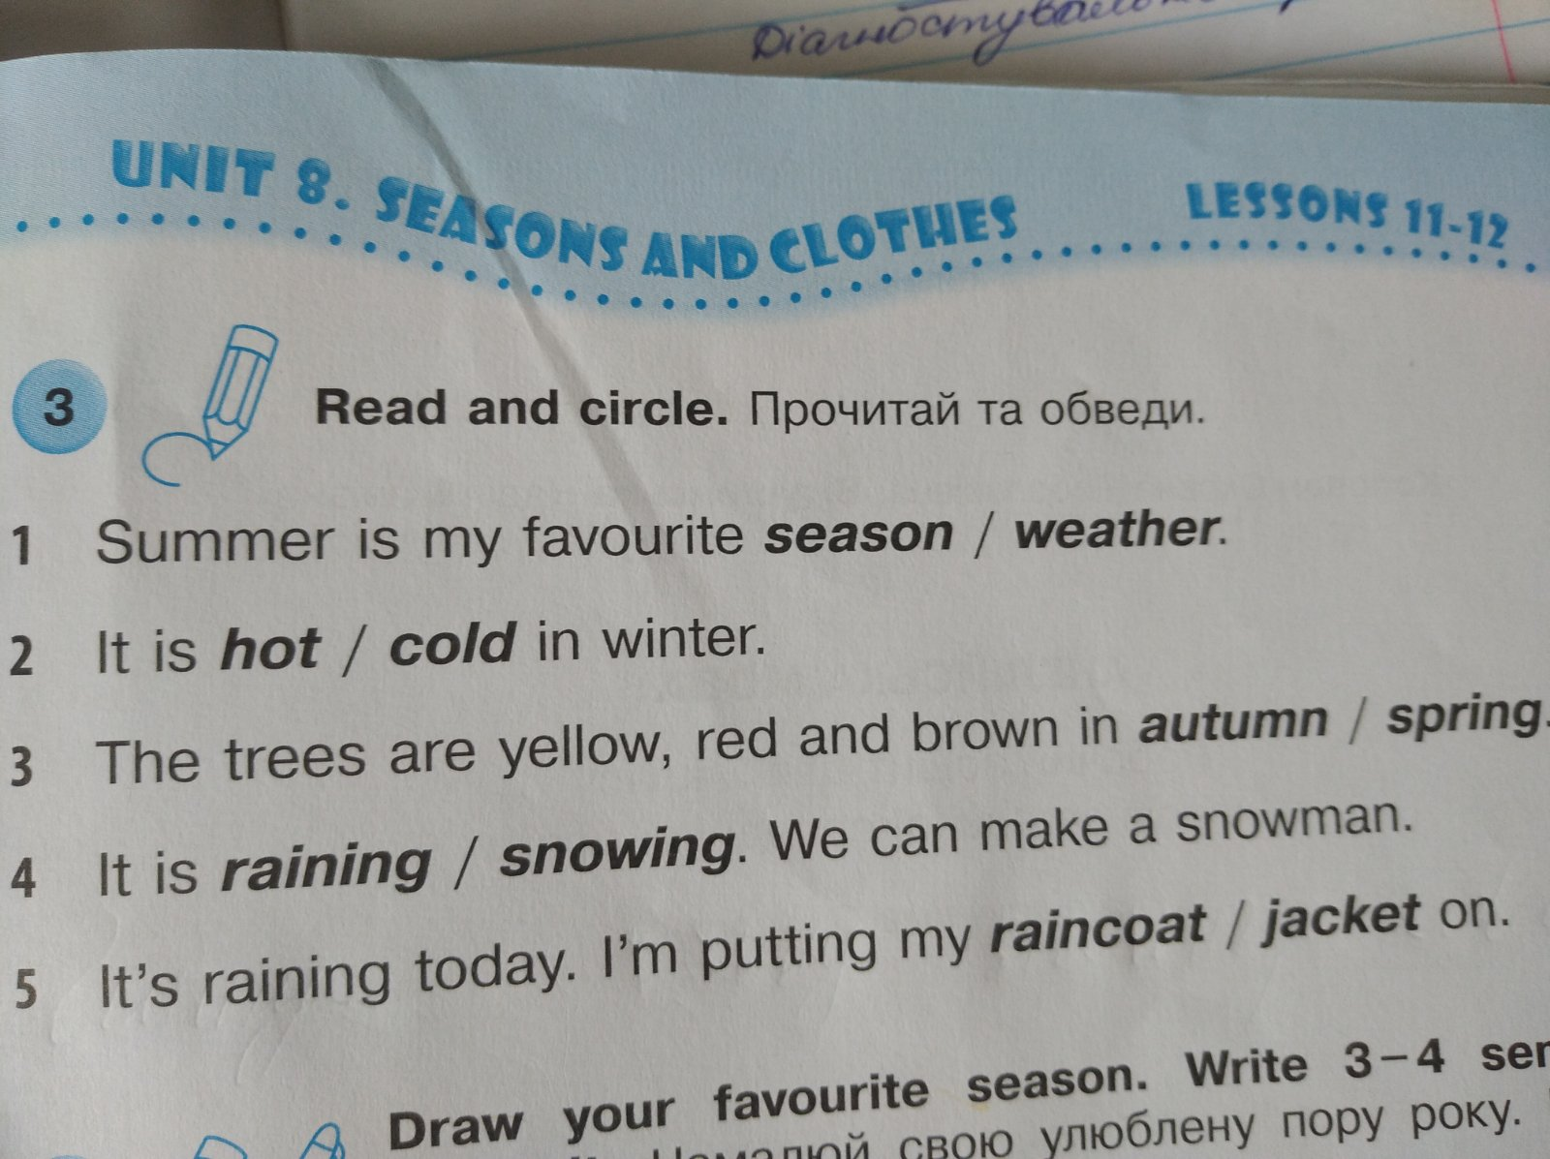

3 клас

**Тема уроку** «Контроль читання»

Friday,the tenth of June

**Reading**

**Betty**

Hello! My name is Betty. I’m ten. I’m from England. My country is big. I live in London. London is a big city.

I have got a family. My family is small. I’ve got a father, a mother and a brother. My dad’s name is Tom. He is a businessman. My mum’s name is Mary. She is a teacher.

I go to school №15. I learn English on Mondays and Fridays. My hobby is music and I like to play tennis very much.

I have got a rabbit. It is grey and it lives in a big box. My brother likes to play with my rabbit. I like to go for a walk my dog in the park.

1. **Mark true or false**
2. Her country is little.
3. She lives in the city.
4. Her family is big.
5. Her mother’s name is Susan.
6. She goes to school №15
7. She learns English on Mondays and Wednesdays.
8. **Choose the right item**
9. The girl’s name is …
10. Ann
11. Betty
12. Kate
13. She is …
14. eleven
15. six
16. ten
17. She is from …
18. England
19. Australia
20. Ukraine
21. She lives in …
22. village
23. town
24. city
25. Her father is a …
26. businessman
27. teacher
28. seller
29. She learns … at school.
30. Italian
31. Ukrainian
32. English
33. **Answer the questions**
34. What does Betty’s mother do?
35. What are Betty’s hobbies?
36. What pets has she got?