3. USE OF ENGLISH
Read the text. Choose one of the variants A, B, C or D.

Big Ben is known as Great Britain’s most famous clock and one of London’s (1)… known sights, situated on the bank of (2)… river Thames being an important part of the city’s skyscraper. It’s popular both with visitors and Londoners.
There is some misunderstanding as to the name itself. Some people refer it to the clock tower itself, (3)… use the name just to the clock. Factually, strictly speaking the name Big Ben is the name of one bell, the largest bell in the clock.
Irrespective of the definition, Big Ben is massive. The tower is 316 foot high. (4)… of the four faces of the clock is 23 foot square and the figures are each 4 foot tall.
There are some legends as to the origin of the name Big Ben. Some people consider it (5)… about during the parliamentary debate to consider naming the clock – after Sir Benjamin Hall, who was known as ‘Big Ben’.
Another possibility is that the name referred to Benjamin Count, a heavyweight boxing champion of the time (6)… nickname was ‘Big Ben’.

3. USE OF ENGLISH
Read the text. Choose one of the variants A, B, C or D.

The famous circus, Cirque du Soleil, is known all over the world. It started performing in Montreal, Canada. It was organized (1) … the Canadian Guy Laliberte in 1984. The first show was a striking, dramatic mix of circus arts (without animals) and street performance that featured magical lighting and original music. He named it Cirque du Soleil because, in his own words, “The sun symbolizes youth, energy and strength”.
After leaving college, Laliberte travelled all over Europe earning money (2) … music in the open air. After returning home, he began Cirque with (3) … friend, Daniel Dauthier. In the 1990s, Cirque quickly expanded. It now shows the performances (4) … over the world and the stuff working for it has grown from 73 to (5) … than 3,500. The Cirque doesn’t work with animals, but (6) … is music and dance and each show is like a story.

3. USE OF ENGLISH
Read the text. Choose one of the variants A, B, C or D.

A couple of years ago my Father got a new job. A town where he got it was 100 km from our home. My parents (1) … we would have to move, because it took much time for Father to come to his working place every day.
When they (2) … me about their plan I was upset because I enjoyed my home and school. I was sure I would (3) … all my friends and teachers a lot.
Well, half a year (4) … that, we moved to another town. The house was more comfortable than the old one, and (5) … my bedroom window I could see the sea.
I was worried about the first day at my school. I felt really (6) … about meeting new classmates and teachers. But when I got there everyone was great!

3. USE OF ENGLISH
Read the text. Choose one of the variants A, B, C or D.

There exists a very interesting island in the Pacific Ocean. It’s called Easter Island which is (1) … for its statues. Hundreds of these huge, stone faces can be (2) … all over the island.
The question is who made them. How (3) … they move these giant pieces of rock? Studies show that people first arrived on the island about 1600 years ago. They had a very advanced culture. Many objects were made by them, and they had their own written language. However, the number of people on the island grew and grew (4) … it reached about 10,000 people.
It happened so that there were too many people and there wasn’t (5) … food to eat. A terrible war happened and many of the statues were destroyed. When western explorers (6) … the island on Easter Day in 1722, the huge rock statues were the only sign of the existence of a great society once living there.

3. USE OF ENGLISH
Read the text. Choose one of the variants A, B, C or D.

Turtles spend most of their life in the sea. They have a hard shell over their body and they can pull their head, arms and legs inside the shell (1) … they are in danger. Turtles (2) … live for one hundred years and grow up to two metres long. (3) … year, the mother turtle swims to a beach to lay her eggs. (4) … a month later, the eggs break open and the baby turtles (5) … to get into the sea. They are very small and (6) … have problems getting to the water.
Several years later, these baby turtles will return to the same beach to lay their eggs. People think they find the way by following the light from the moon or the stars.

3. USE OF ENGLISH
Read the text. Choose one of the variants A, B, C or D.

Leonardo da Vinci was born in 1452 and died in 1519. In his lifetime, this extraordinary man was a scientist, mathematician, engineer, inventor, anatomist, painter, sculptor, architect, botanist, musician and writer.
Leonardo the artist painted two of the (1) … famous paintings of all time: the Mona Lisa and the Last Supper. He (2) … as an artist for a number of years before he became (3) … in science and engineering.
He wrote descriptions (4) … the natural world and made many drawings of human anatomy, which he kept in his journals. (5) … was curious about these descriptions was the fact that Leonardo wrote (6) … in mirror-image, which means you can only read them with the help of a mirror.

3. USE OF ENGLISH
Read the text. Choose one of the variants A, B, C or D.

Read some rules of good manners and try to follow them.
Don’t use a spoon for what can be (1) … with a fork. Place vegetables, garnish, pasta on your fork with the help of your knife. Cut (2) … in small pieces to chew it easily. Cut off one piece at a time.
Don’t blow on your food if it is too hot; you don’t start a campfire (3) … a damp night.
Spoons, knives and forks shouldn’t be banged against your plate.
While eating, try to make as little noise (4) … possible. Don’t sip your (5) … as though you wanted the whole house to hear.
Don’t talk with your mouth full. Don’t pick your teeth in company after the meal even if toothpicks are provided for the purpose.
Try not to put your elbows on the table.
And finally, don’t (6) … to say ‘thank you’ for every favour kindness.

3. USE OF ENGLISH
Read the text. Choose one of the variants A, B, C or D.

People generally eat more in winter than in summer, (1) … you want to lose weight and stop feeling tired all the time, (2) … isn’t enough. You also need to (3) … some simple exercise. The first thing you can do is to get outside. Walking during winter is better than walking in summer because you can go on for longer distances in cold temperatures. Aim for a speed (4) … you can achieve comfortably.
Another easy way to (5) … fit is by following an exercise video. There’s no need to spend time travelling to and from a class, you simply switch (6) … the video and work out at home. Something else you can do at home is walking up and down stairs. Five to ten minutes of this is excellent exercise.

3. USE OF ENGLISH
Read the text. Choose one of the variants A, B, C or D.

People all over the world know Maxwell House Coffee brand. Here is a bit of history.
In 1873, a grocery salesman named Joel Cheek became interested (1) … coffee and made his own unique blend. Realizing that he (2) … a fine brew, he decided to sell it. One of the South’s (3) … hotels, the Maxwell House, liked his coffee and began to serve it to guests; hence the name Maxwell House Coffee.
In 1907, on returning from a bear hunt in (4) … Mississippi, President Theodore Roosevelt was a guest of the Ladies Hermitage Association at Andrew Jackson’s homestead in Nashville Tennessee. He (5) … a cup of Maxwell House Coffee. He remarked on the excellent quality of the coffee and uttered the famous line, “Delightful. This coffee is good to (6) … drop”.

3. USE OF ENGLISH
Read the text. Choose one of the variants A, B, C or D.

A poor young artist was asked to (1) … the portrait of a (2) … lady and he did his best to make a good picture. When the portrait was finished, it was shown to the (3) … friends. Some of them thought it was too realistic. They were afraid the lady wouldn’t like the picture. But the painter (4) … he had been (5) …and he didn’t want to change anything.
Then one of his friends suggested the following, “We will leave it to the lady’s dog whether the picture is good or bad”.
The next day the picture was sent to the lady’s house where her friends had gathered to see the result of the test. As soon as the dog was brought before the portrait, it began to lick it all over. Everybody congratulated the painter.
Do you think the dog recognized (6) … mistress?

3. USE OF ENGLISH
Read the text. Choose one of the variants A, B, C or D.

There are many stories about different people’s ways and habits. When we think how Englishmen behave, they are considered to be naturally polite and are never tired (1) … saying ‘Thank you’ and ‘I am sorry’.
People are sure they are (2) … disciplined. You think they’ll never (3) … loud (4) … in the streets and are never in a hurry.
It’s generally believed that they never rush for seats in buses and trains.
It’s a custom for English people not to shake hands when meeting one (5) … . They just smile and (6) … ‘Hallo’. They say ‘How do you do’ sometimes, but not very often, only to people they meet for the first time.

3. USE OF ENGLISH
Read the text. Choose one of the variants A, B, C or D.

Britain has the reputation of a sporting nation, that is why most of sport terms are English.
Speaking about sport, it is an essential part of the Englishmen’s daily life. Of all sports at least two have the greatest popularity (1) ... Britons: football in winter and golf in summer. One can (2) … mention rugby, a form of English football in which the players (3) … their hands for carrying the ball. The game is played by a (4) … of 15 men with an oval ball. (5) … sports such as tennis, cricket, boxing are also very popular in England. Young people do athletics. But people who are fond of fishing or hunting (6) … with their sports even in middle age.

3. USE OF ENGLISH
Read the text. Choose one of the variants A, B, C or D.

Many people are interested in visiting new and interesting places. Tourism, the act of paying money to go from one place to (1) … to see different and unique sights, (2) … a fact of civilized life since approximately the 12th century. Of course, back in (3) … days it was basically the upper classes that had the time, the money and the interest in travelling from spot to spot.
The word ‘travel’ by the way comes from the medieval English word ‘travail’ which means suffering great hardship and that is a very good description of travel in the earliest days. Much has been written about the journeys of Marco Polo, who until recently was considered the (4) … first tourist.
Celebrated in books, movies, musicals and television specials in several countries, Marco Polo is today a hero in Italy and China: Venice named its airport after a beloved native son. There’s the Marco Polo bridge outside Beijing, and no tourist to the Chinese capital in (5) … was ever allowed to miss the Marco Polo Carpet Shop at the Temple of Heaven. Across Asia, in tributaries of the storied Old Silk Road that linked West and East, Polo’s name (6) … modern travellers to restaurants, hotels and souvenir shops.

3. USE OF ENGLISH
Read the text. Choose one of the variants A, B, C or D.
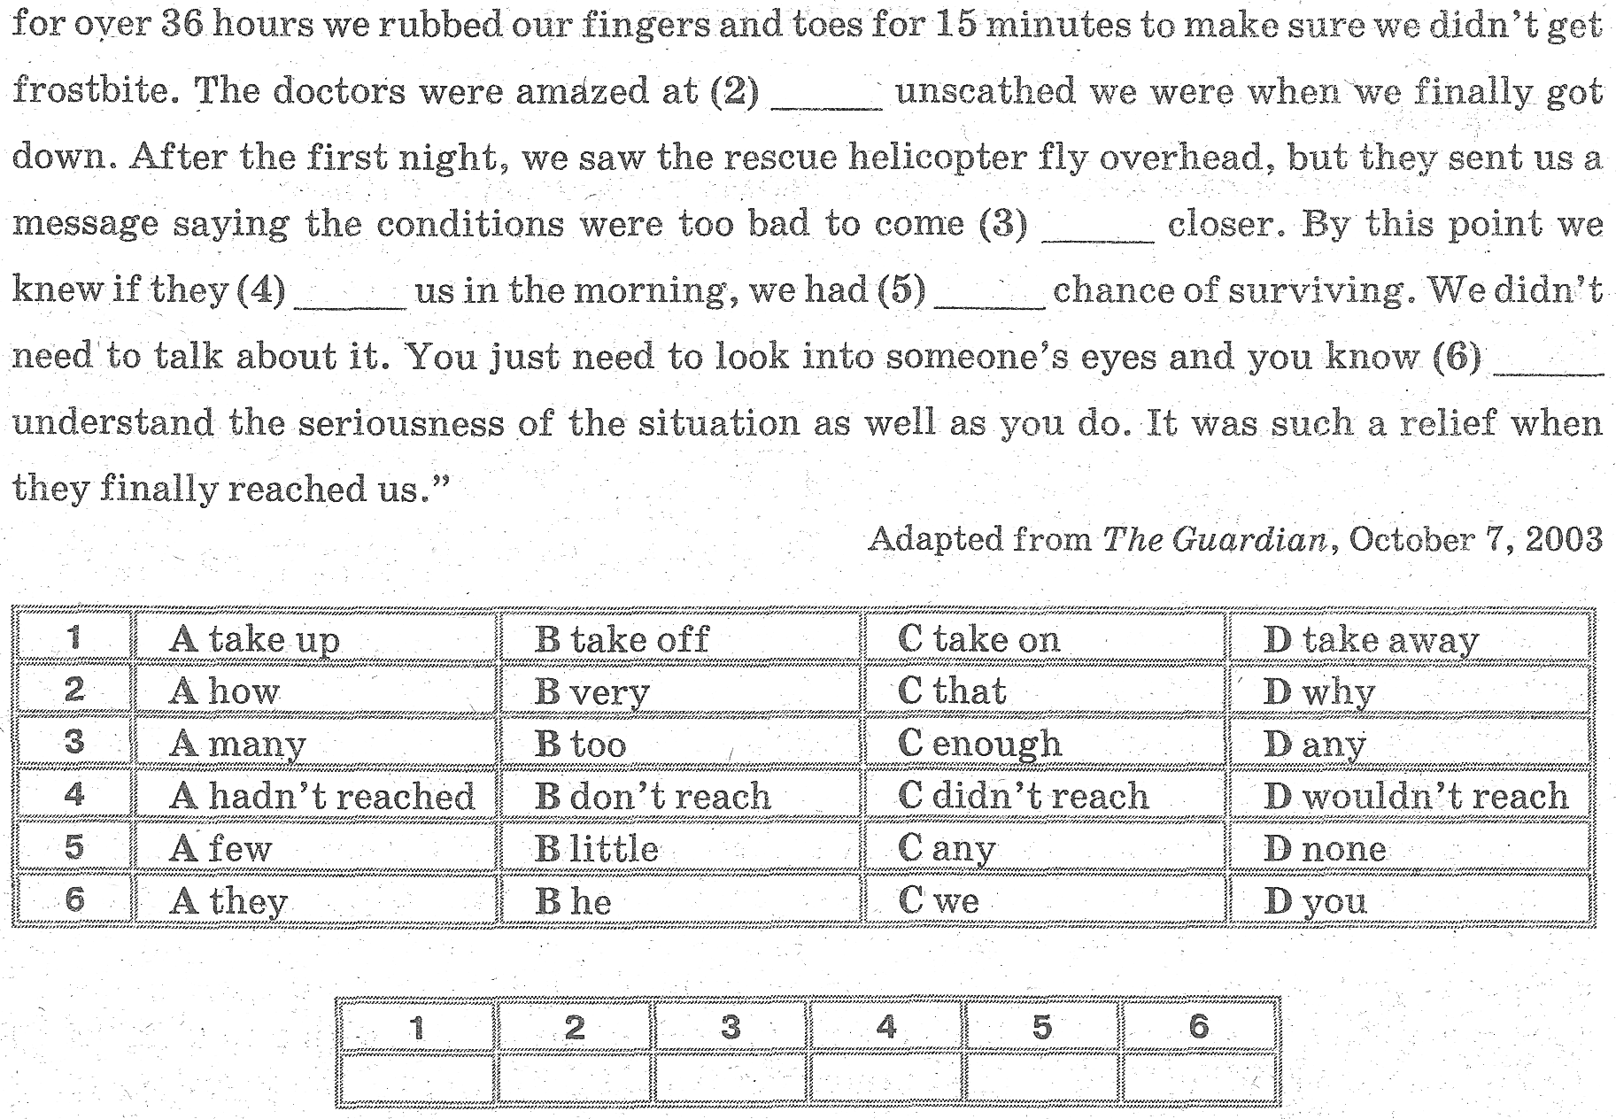

3. USE OF ENGLISH
Read the text. Choose one of the variants A, B, C or D.


