**Form 5 Name:**

**Listening Comprehension**

**Term 1**

**Variant I**

**Task 1. Listen to the text and tick Mark on the photo.**

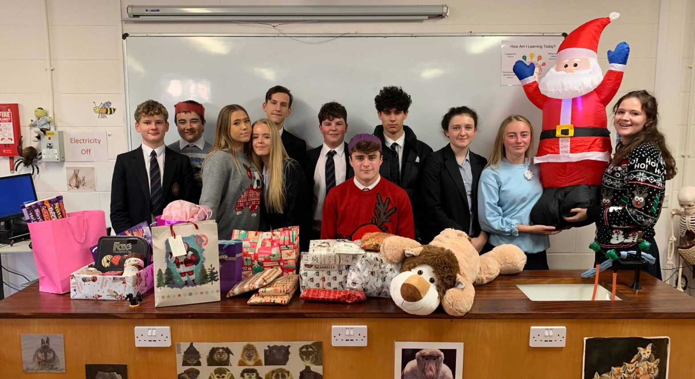

**Task 2. Listen to the text. Mark the sentences True or False.**

|  |  |  |
| --- | --- | --- |
| 1. | Mark`s hair is straight. |  |
| 2. | Mark is good at Geography. |  |
| 3. | Mark plays basketball well. |  |
| 4. | Daniel is Mark`s best friend. |  |

**Task 3. Complete the sentences.**

|  |
| --- |
| ***difficult, projects,form,Geography*** |

1. Mark and Daniel are in the fifth ________________________________________ .

2. Maths is ______________________________________________________ for Mark.

3. Daniel`s favourite subject is ____________________________________________ .

4. Mark`s classmates make ______________________________________ together.

Mark:

**Form 5 Name:**

**Listening Comprehension**

**Term 1**

**Variant II**

**Task 1.** Listen and tick Daniel on the photo.



**Task 2. Listen to the text. Mark the sentences True or False.**

|  |  |  |
| --- | --- | --- |
| 1. | Mark`s hair is brown. |  |
| 2. | Mark`s favourite lesson is Geography. |  |
| 3. | Daniel is good at tennis. |  |
| 4. | Mark`s classmates have pen friends from other countries. |  |

**Task 3. Complete the sentences.**

|  |
| --- |
| ***tennis, classmates,lessons, English*** |

1. Mark`s favourite subject is _____________________________________________ .

2. Mark and Daniel are __________________________________________________ .

3. Daniel is good at ______________________________________________________ .

4. They make projects and play football after the _________________________ .

Mark:

Hello, I am Mark. I`m 11 years old. I`m in the 5th form. I am tall. I`ve got curly brown hair and brown eyes. I like English. It`s my favourite subject at school, but Math is difficult for me. Also I`m good at football. I attend football club three times a week.

Daniel is my best friend. We are in the same class. He is tall and thin, he has got strait brown hair and brown eyes too. He likes Geography. Daniel plays tennis well. He also is good at basketball.

Our class is not very big, but we`re great. We make projects together. We play football in the schoolyard after the lessons. We`ve got pen friends from the USA, France and Germany. We`re happy to be in the same class.

**Form 5 Name:**

**Reading Comprehension**

**Term 1**

**Variant I**

**Task 1. Read the text.**

My name`s Peter. I`m ten and a half. My hobby is collecting coins. There are 37 coins in my collection. Some of them are expensive. My dad helps me to buy new coins for my collection. I also like cycling and make tricks on my bike.

I`ve got two friends. They are Sam and George. They are my classmates.

Sam is kind, polite and imaginative. His hobby is painting pictures. He attends the Art school in our town. He paints nature and portraits of people. I think Sam is a talented person. He also is good at Maths. He helps me with my homework sometimes. Sam is very clever.

George is funny and curious. He likes travelling. He has been to France, Italy and Spain with his parents. George also likes collecting unusual badges.

I like my friends. We have much fun together.

**Task 2. Draw lines connecting George with his hobbies.**

**George** 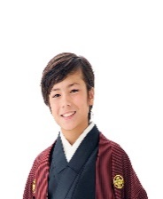

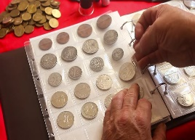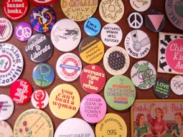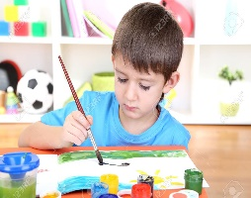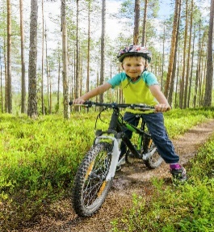

**Task 3. Mark the sentences True or False.**

|  |  |  |
| --- | --- | --- |
| 1. | Peter likes cycling. |  |
| 2. | Sam and George are Peter`s classmates. |  |
| 3. | Sam is funny and curious. |  |
| 4. | Sam attends a Music School. |  |
| 5. | George collects coins. |  |

**Task 3. Complete the sentences using the words from the box. There is one word you don`t need to use.**

|  |
| --- |
| ***homework, portraits, collecting, collection, hobby*** |

1. Peter has a lot of coins in his ________________________________________ .
2. Sam can paint ____________________________________________ of people.
3. Sometimes Sam helps Peter with ____________________________________ .
4. George`s hobbies are travelling and ________________________________ .

Mark:

**Form 5 Name:**

**Reading Comprehension**

**Term 1**

**Variant II**

**Task 1. Read the text.**

My name`s Peter. I`m ten and a half. My hobby is collecting coins. There are 37 coins in my collection. Some of them are expensive. My dad helps me to buy new coins for my collection. I also like cycling and make tricks on my bike.

I`ve got two friends. They are Sam and George. They are my classmates.

Sam is kind, polite and imaginative. His hobby is painting pictures. He attends the Art school in our town. He paints nature and portraits of people. I think Sam is a talented person. He also is good at Maths. He helps me with my homework sometimes. Sam is very clever.

George is funny and curious. He likes travelling. He has been to France, Italy and Spain with his parents. George also likes collecting unusual badges.

I like my friends. We have much fun together.

**Task 2. Draw lines connecting Sam with his hobbies.**

**Sam** 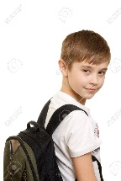



**Task 3. Mark the sentences True or False.**

|  |  |  |
| --- | --- | --- |
| 1. | Peter collects badges. |  |
| 2. | Sam is an imaginative and talented person. |  |
| 3. | Sam likes travelling. |  |
| 4. | George is curious. |  |
| 5. | George collects coins. |  |

**Task 3. Complete the sentences using the words from the box. There is one word you don`t need to use.**

|  |
| --- |
| ***person, travelling, collecting,expensive, parents*** |

1. Some coins in Peter`s collection are _________________________________ .
2. Sam is an imaginative ______________________________________________ .
3. George travels with his _____________________________________________ .
4. George`s hobbies are collecting and ________________________________ .

Mark: