***OUR HOLY NATIVE LAND***

***Legend of the village of Vovchatychi***

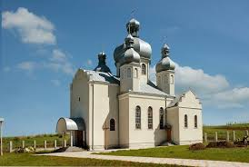

On the bank of the river Luh, surrounded by forests and meadows is situated a picturesque village Vovchatychi.The village got the name from some Volchaty (the village inhabited by descendants of Volchaty).

But there is another version. East of Vovchatychi there is a grave, which in ancient times (in pre-Christian times) could be some fortifcation. The inhabitants of the settlement could move (perevolochuvaty) there certain goods from the River Luh.

Another suggestion is that the name of the village derives from the word «volok» (drag net). «Volok» is a net, which was used to catch the fish walking in shallow water. It is possible that when the water level was higher the present Vovchatychi place was a flooded valley in which fishing occurred regularly. It could be called»volochytsya» and people who were mainly engaged in fishing there were volochatychi.

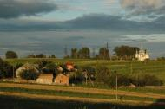

     Local residents tell another legend about the name of the village. Once upon a time there were forests in the area. And terrible wolves lived there. It was difficult to walk through the forest. People took with them big sticks that locals called tychi.They used them to defend themselves from wolves. Hence the name – wolf`s tychi – Vovchatychi.

***The legend of the Virgin of Verbitsya***

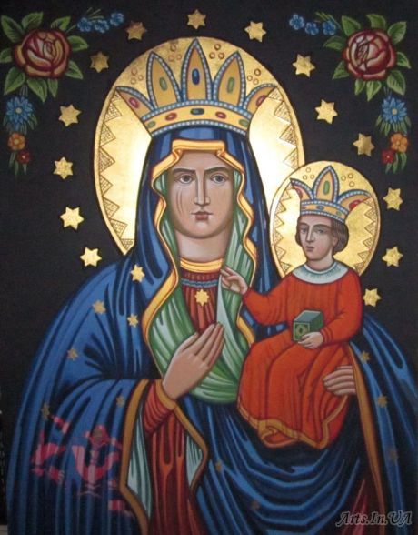      In the place where now in the village of Verbitsya there is a clinic once there was the house in which a teacher lived. She had a maid. Once a maid went to bring water from the well. She saw light in the well. Terribly frightened, the servant ran to master of this well, saying: "Papa, go to the well there is " bitch " there. When all came together to a pit, they saw only an image of the Virgin. The Pure was offended by this attitude to her and by the groundwater she reached Zarvanytsya, where she manifested herself. When the priest has consecrated in Zarvanytsya the image of the Blessed, then on the other side of the icon was the inscription "a relative of Verbitsya ,a resident of Zarvanytsia."

    In this village the old told stories of the restoration of the Holy Virgin icon.

      In the place where now the Barschynsky family lives in the village, once stood a clay hut. Here lived the old man with a wife and they had no children. They were decent and honest people. Once the house owners noticed that their old image of the Virgin Mary was shining. They were very scared, called neighbors, and prayed for a long time. The news quickly spread through the whole village. With a priest people came together on the scene. The priest celebrated Mass. Then the icon was placed in the local St. Archangel Michael church where it is to this day.

       And so on July 15 in honor of the anniversary of the renewal of the image of Our Lady in the village of Verbytsya in the St. Archangel Michael church great celebrations are held - Release-pilgrimage to the Mother of God called "go to Mary."

***Holy Well***

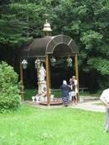An interesting legend about one of the “holy wells” in Zhydachiv district, which is connected with the history Borynychi chapel. In the old days this area was surrounded with dark dense forests (bory) which gave Borynychi its present name. Just with this village is connected the story of a" holy well ".

There is no evidence who discovered the healing spring. There is only a legend, that it was opened very - very long ago by devout people who saw light and image of Our Lady in the place at night.

The well is located in the forest on the border of four villages. People began to come here from time immemorial to the present, bringing to this miraculous water different physical ailments. Once a deaf girl recovered from serious illness drinking water from it. To mark this event in 1863 Count V.Borkovskyy built a chapel decorated with a dome and a bell tower opposite the well. People established the Virgin figure . A holy place was worshiped for years until Soviet government came to Western Ukraine.

One day, the figure of Our Lady was destroyed and scattered through the forest. People found these pieces, restored the figure but could not find the head of the Virgin. But once the Virgin appeared before one Borynychi resident in his dream and said: "The head of the figure is in well under silt. Go and dig it. " The man got up early and went to the chapel to dig but found nothing. The second night he again dreamed of the Mother of God, who said, "Dig and you`ll find". He again began digging and found the head.

***Legend of the icon***

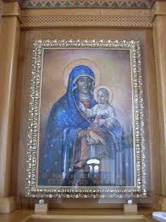 According to the legend in 1646 Mrs. Anna Voynakovska rode to the city of Zhydachiv. Suddenly the carriage stopped and four horses fell on their knees in front of an old oak. Anna saw the icon of the Virgin Mary with Baby Jesus on Her arms.

A painted board thrice returned to its favourite oak the first night after the transition.

In1680 on the site of the oak a wooden chapel was built and the icon was placed there(chapel stands to this day). Thanks to that icon a lot of people became healthy .In 1931 the monks of the Society of Jesus decided to make a copy of the icon to prevent it from destruction.The original icon is the town of Glivitse in Poland now,not in Kokhavyno.

***Zhydachiv Lady of the Incarnation of the Lord.***

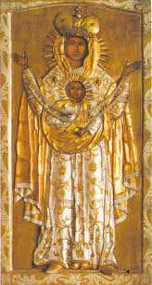In the city center there is a kind of ecumenical area, with three churches of different denominations: the Church of the Resurrection (Church), Church of the Assumption of the Virgin Mary (Roman Catholic Church) and the Church of All Saints (UCC CP). By the way, the Church is considered to be the oldest preserved monument of sacral architecture of the city.

In the Church of the Resurrection there is Zhydachiv icon of Our Lady of the Incarnation of the Lord. According to legend the icon was brought by the Dniester somewhere in the XIII century. First it was put in the church of the village Piatnychany, but the next day the relic disappeared mysteriously and was again on the river. Then it was decided to give the icon to the Zhydachiv temple where it remains today.