4 клас ( 02.11.2021)
https://meet.google.com/ooq-rupw-fdr — Посилання на відео урок. Початок 8.30.

Тема уроку: У будинку.
Обладнання: телевізор, роздатковий матеріал, ілюстрації для роботи в групі, музичне відео.

Хід уроку. Procedure.
І. Організаційна частина.
1. Привітання. Greetings.
Good morning,
What a nice morning!
The day is sunny and so bright
My dear children Am I right?- you are right.

2.Мовна розминка. Warming up. Введення в іншомовну атмосферу.
1.What’s your name?
2.What’s your surname?
3. How old are you?
4.Where are you from?
5.Do you live in the country?
6. Do you live in a town?
7.Where do you live?
8.What street do you live in?
9.Do you live in a house?
10. Do you live in a flat?
9. How many rooms are there in it?
10. What’s your room like? What is your favourite room?
ІІ.Основна частина. Main part.
1. Повідомлення теми уроку. Мотивація навчальної діяльності. Aim.
Today we have got an unusual lesson. If you do this interesting task you will get to know the theme of our lesson.

2. Сприйняття та усвідомлення.
А) Фонетична розминка.
І кімната-A hall.Звучить загадка про коридор.
It’s downstairs. It’s the first room when you come into the house. It’s neither large nor small. Usually you take off your coat and a hat there.( It’s a hall).
Завдання учнів виконати завдання та пройти до іншої кімнати.
Let’s train our tongues. Let’s repeat some sounds, please.
All[ o:l]-hall, ball,tall,call, small.
oo [u:]-room,book,look, took.
Ch [tf]-kitchen, chair.
Ur[3:]-curtain
Thank you for your work.And what task is the next room? Would you like to get to know?-OK.
Б)актуалізація опорних знань. Прийменники місця.( The prepositions of place)
ІІ кімната-A living room.
Please, listen to the next riddle .Be attentive.
It is a room,where you can have a rest, watch TV, read books there. What room is this? ( This is a living room)
-At this room we also have an interesting task. But first of all let’s remember the prepositions of place.
Фронтальне опитування: Т-Р
Above-над
Between-між
In front of –попереду
Behind-позаду
In the middle of-посередині
On-на
In the corner of-в кутку
Game” Catch the fly”( Спіймай муху за допомогою рухів)
1. Catch the fly aboveyour head.( Плеснути над головою)
2.Catch the fly between the desks.( Плеснути між партами)
3.Catch the fly in front of your face. ( Попереду обличчя.)
4.Catch the fly on the book.(По книзі)
5.Catch the fly behind your chair.( Позаду стільця)
6. Catch the fly in the middle of the desk.(Посередині парти.
7.catch the fly in the corner of the desk(В кутку парти.)
Thank you for your work. I think let’s have a rest and come to another room. Please, listen to the next riddle.
ІІІ кімната- a kitchen.Relaxation.Фізхвилинка
It is a room where you can cook meals. What room is this?
( this is a kitchen).
At this room we can relax and dance.( Song “Clean up”.Вчитель виконує разом з учнями).
4 кімната- a Bathroom. Project work. Створення міні-проектів. Робота в групах. 3 групи
Riddle: It’s a room where you can wash your hands you face, clean your teeth, take a shower there. What room is this?( a bathroom).
Let’s clean up another rooms.At the blackboard you can see the furniture. Your task-choose the furniture and stick to the necessary room and then make up the sentences using the structures there is /there are. Work in groups and help each other.
The first group-a kitchen
The second group-a bedroom
The third group- a bathroom
5 кімната.-a bedroom. Writting. Розвиток навичок письма.
Riddle: It’s a room where you can sleep there. What is this?( a bedroom)
Take a card and do the next task. Unscramble the words. Перестав літери та запиши слова.
Henkitc-kitchen ombathro-bathroom
Allh-hall ingliv orom-living room
Oombedr-bedroom tetoil-toilet
Ingdin oorm-dining room ldren’schi rmoo-children’s room
6 кімната-a children’s room. Listening. Розвиток навичок аудіювання.
Riddle: This is n my favourite room. It’s large clean and cosy. You can have a rest and play there. What room is this? ( a children’s room)
Do you like to draw? The next task also will be very interesting and help you to develop your imagination. Your task is to listen to the description of the room and draw the necessary things.
The description: this is a living room. There is a ball under the table. There are long curtains on the window. There is a bookcase next to the window. There is a cat on the carpet. There is a clock above the sofa.
Are your pictures so as at the blackboard? A right picture is on the wall.
Зі зворотної сторони дошки знаходиться правильний малюнок-діти перевіряють правильність виконання завдання- взаємоперевірка.
7.Розвиток навичок читання .Reading.
Словникова робота.

Використовуючи малюнки повторити слова із завдання.
Читання тексту ланцюжком.
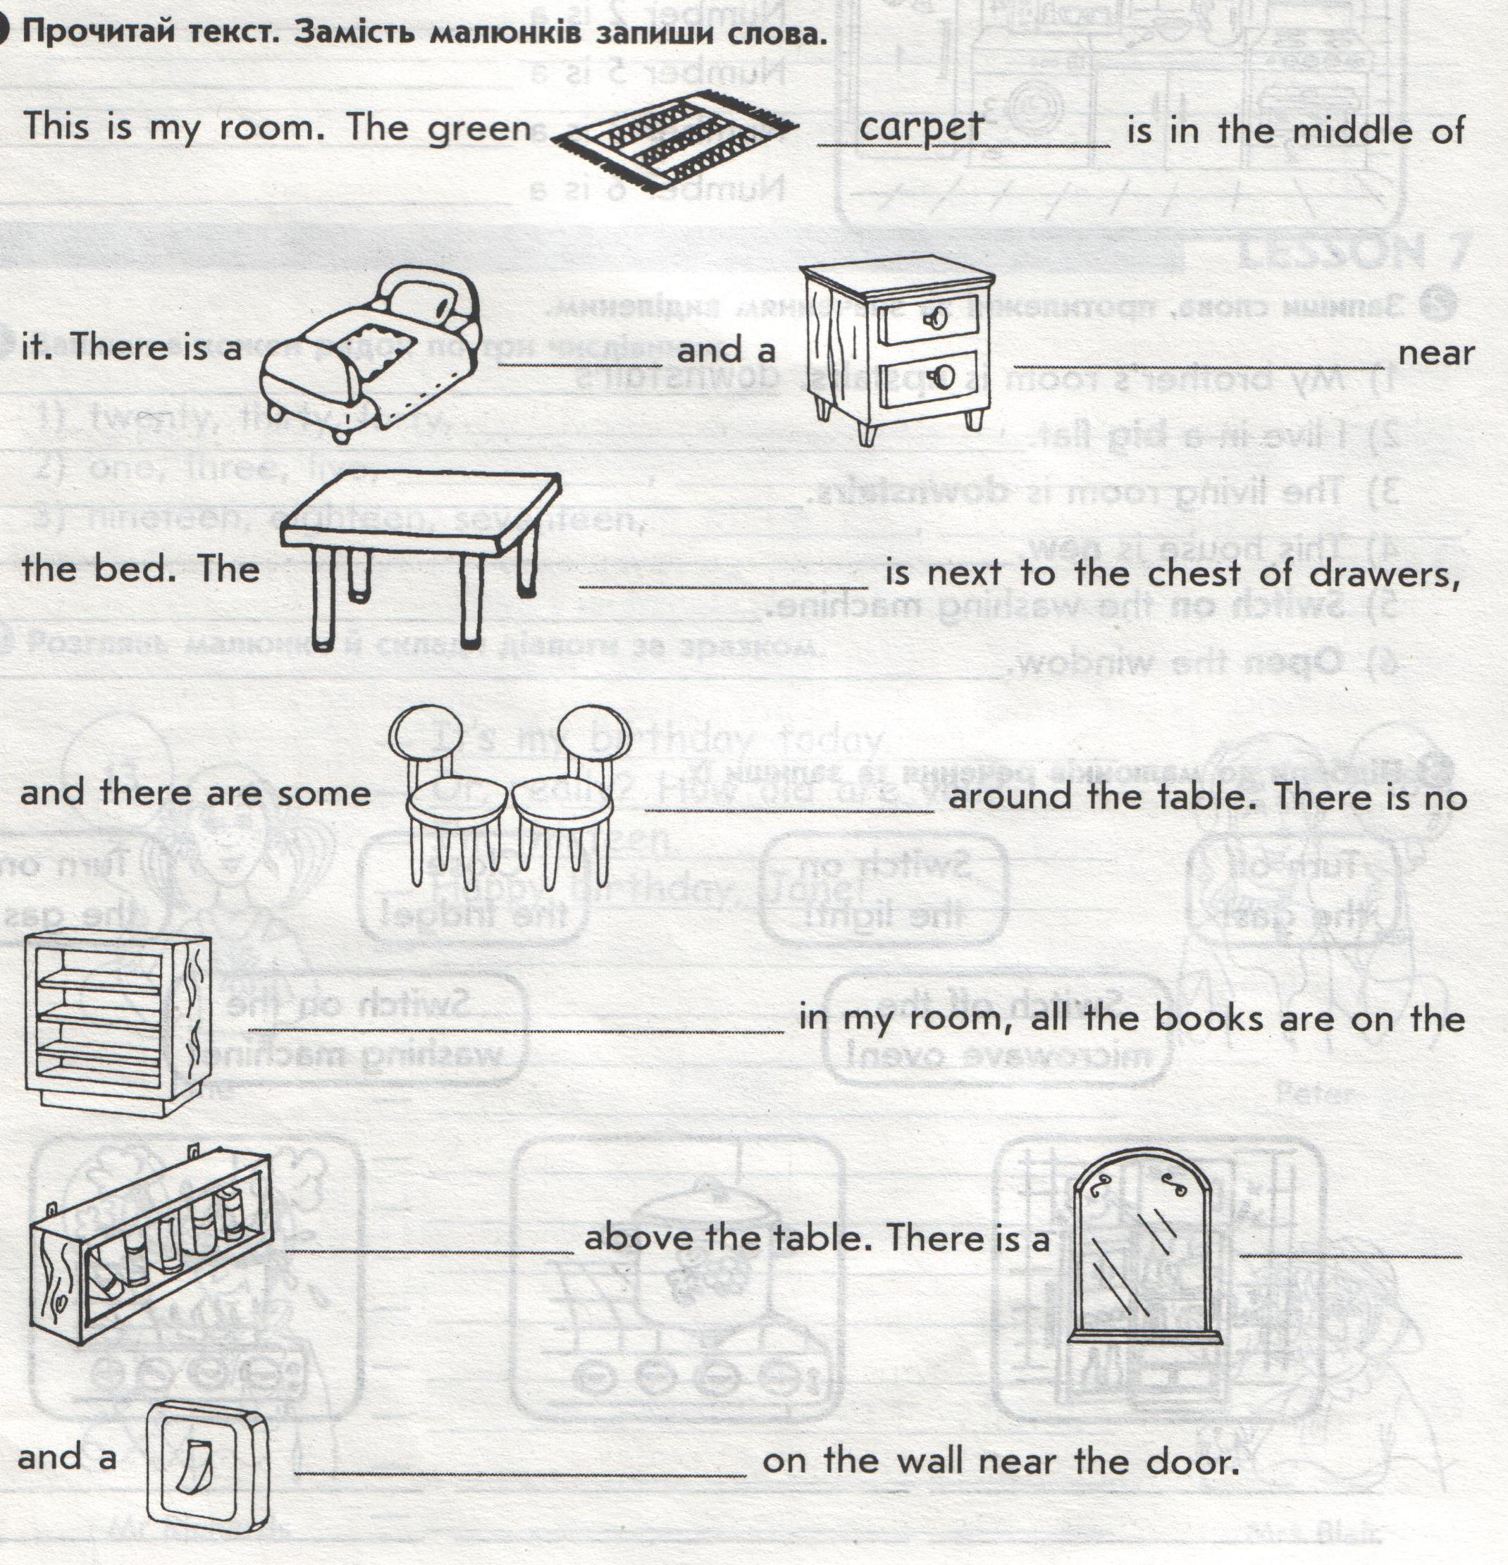
Перевірка сприймання прочитаного. Запитання-відповіді.
ІІІ. Заключна частина.Summing up.
1.Reflection. Підведення підсумку уроку. Рефлексія.
2.Оцінні судження .Marks.
3.homework.
Your task for the next time is…( 2 cards)(За бажанням картки на вибір).
That’s all for today. Be happy all the time.Our lesson is over. See you next time.

4 клас (04.11.2021)
http://meet.google.com/tun-hwrx-kfc — Посилання на відео урок. Початок у 8.30

Тема уроку: Моє місто
Мета уроку:
Практична: Через урок занурити дітей у англомовне середовище, повторити з учнями матеріал з тем “ Моє місто”. Закріпити навички читання, аудіювання, говоріння, письма.
Освітня: Закріпити в учнів розуміння граматичного правила по утворенню запитальних речень у Present Simple Tense, застосувати його на практиці. Вчити правильному порядку слів у реченні.
Розвиваюча: Розвивати в учнів мовлення, фонетичний слух, навички розуміння і виконання команд вчителя англійською мовою, тренувати учнів у читанні англомовного тексту, ровивати навички аудіювання, говоріння.
Виховна: Через урок виховувати в учнів любов до англійської мови. Виховувати турботливе ставлення до всіх членів родини.

Граматичний матеріал: Теперішній звичайний та теперішній подовжений часи.
Структури: Структура «to be going to do smth.” – збиратися щось зробити.

Хід уроку:

І. Підготовка до сприйняття іншомовного мовлення
1. Привітання
- Good morning, children! I am glad to see you! Sit down, please.
- How are you?
- What's the date today?
- What's the weather like today?
- Who is absent?
- What was theme last lesson?

1.1. Фонетична зарядка
- Назвіть звуки і слова, в яких ці звуки зустрічаються.
- Повторіть скоромовку:

The twenty-two train break through tunnel.
Двадцять два потяги прорвались через тонель.
2. Перевірка домашнього завдання
- What was the homework?

3. Актуалізація опорних знань
Інтерактивна вправа « Асоціативний кущ»
- Нow can we travel? (ground transport, underground transport, water transport, air transport)
ІІ. Основна частина
- Робота зі словником
- Write new words in the dictionary:
an airport – |ˈerpɔːrt| - аеропорт
to wait for smb./ smth. – |weɪt| - чекати
by plane – |pleɪn| - на літаку
to arrive on time - |əˈraɪv|- прибути за розкладом
- Робота з підручником
  - Вправа 2 с.74
- Look at the picture and answer the questions.
2.2. Читання тексту (c.74 впр.3а)
- Let’s read the text and then answer the question.
2.3. Тренування діалогічного мовлення у парах
- Work in pairs. Take turns to ask and answer the questions.
- Фізкультхвилинка
Head and shoulders, knees and toes, knees and toes,
Head and shoulders, knees and toes, knees and toes,
Eyes, and ears, and mouth, and nose,
Head and shoulders, knees and toes, knees and toes.
- Тестування (c.75 впр.4)
- Choose and write agree answer.
ІIІ. Кінець уроку (Summing)
1) Виставлення оцінок.
2) Підведення підсумків.
- Зі значенням яких нових слів ми сьогодні познайомились?
3) Домашнє завдання.
Your homework is p.75 ex.5. Look at the picture and write 6 sentences about it.
-So, our lesson is over. Goodbye, children!

4 клас ( 04.11.21)
Тема: Будівлі на моїй вулиці
Мета:
розвиток уваги, пам'яті, логічного мислення;
розвиток умінь говоріння, письма, діалогічного мовлення;
узагальнити лексичний та граматичний матеріал з вивченої теми;
розширити кругозір з теми, що вивчається.

Хід уроку
Мовленнєва розминка.
Good morning children. I'm glad to see you. Today at the lesson we are going to talk about things that we usually do when we have spare time. We can be busy with different occupations, but it, of course, depends on the season and weather, if we are outdoors. That's why we must know:
What season is it today?
What month is it today?
What day of the week is it today?
What data is it today?
What is/is not the weather like today?
Основна частина уроку
- It is very interesting for everyone if you go in for any sport or play any musical instrument, if you enjoy some things or are interested in some things etc. Communicate on this topic and our multimedia blackboard will help you. Ask and answer some questions.
For example:
1) Do you go in for sports? What sports do you go in for?
2) Do you play any musical instrument?
3) Do you enjoy sewing (knitting, reading books, collecting things, telling ghost stories…)?
4) Are you interested in going to museums (to the park, at the concerts, to sport contests)?
5) Are you good at cooking (drawing, gardening, writing stories)?
6) Do you take part in sport competitions (concerts, school parties)?
b) We have another way of spending free time. It is making parties. We know different kinds of parties. Now, let's read the texts about parties (ex. 1) translate them and answer the questions:
1. What kind of party is this?
2. What do usually children do at this party?
3. Do you like this kind of party?
c) You know enough ways of spending spare time. You have some lines with words. Make up a poem of the lines and tell what you usually do at your free time. Stamps and postcards
And badges too
Do you collect things?
Yes, I do.
Tennis and football
and volleyball too.
Do you play a sport?
Yes, we do.
Piano and violin
and guitar too.
Do you play an instrument?
Yes, I do.
Фізкульт. хвилинка
Are you tired? Let's have a rest.
a) Tell me please what you can do.
I can walk, I can talk, I can see, I can hear, I can swim, I can jump, I can run, It’s a fun!
Do it if I say "please".
2.Основна частина
d) When we have spare time we usually speak with our friends about different interesting things. Make up two sentences and write them down in your copy-books. Tell us what you like to talk with your friends about (our multimedia blackboard will help you)
For example:
We always talk about music because it is interesting.
e) We know about our pastimes and hobbies a lot. And now look at the table and say about hobbies and pastimes of English people. (ex.2)
For example:
British men rarely visit museums on their free time.
f) Today we spoke a lot about ways of spending spare time. Now let's make a conclusion. Look at the multimedia blackboard and express your attitude to different activities.
For example:
What do you think of collecting stamps?
I think it’s boring!
g) Let's summarize everything you've heard at the today's lesson. Express your idea. (Our multimedia blackboard will help you)
- I am fond of…
- I am keen on…
- I am good at…
- I am interested in…
- I like to…
- I don’t like to…
- I enjoy…
- I take part in…
Завершення уроку
The lesson is coming to the end. Now it's time for home assignment.
Open your day-books and write down your home-task.
- Ex.7, p.90.(a, b)
- Do the presentation of your pastime!
(Schematically)
Giving marks.

4 клас ( 09.11.2021)

http://meet.google.com/mjf-utkt-cmg – Посилання на відео урок. Початок 8.30

"Хобі. Розваги у вільний час"
Мета:
розвиток уваги, пам'яті, логічного мислення;
розвиток умінь говоріння, письма, діалогічного мовлення;
узагальнити лексичний та граматичний матеріал з вивченої теми;
розширити кругозір з теми, що вивчається.
Обладнання:
роздавальні картки-малюнки;
мультимедійний проектор, екран.
Хід уроку
Мовленнєва розминка.
Good morning children. I'm glad to see you. Today at the lesson we are going to talk about things that we usually do when we have spare time. We can be busy with different occupations, but it, of course, depends on the season and weather, if we are outdoors. That's why we must know:
What season is it today?
What month is it today?
What day of the week is it today?
What data is it today?
What is/is not the weather like today?
Основна частина уроку
It is very interesting for everyone if you go in for any sport or play any musical instrument, if you enjoy some things or are interested in some things etc. Communicate on this topic and our multimedia blackboard will help you. Ask and answer some questions.
For example:
1) Do you go in for sports? What sports do you go in for?
2) Do you play any musical instrument?
3) Do you enjoy sewing (knitting, reading books, collecting things, telling ghost stories…)?
4) Are you interested in going to museums (to the park, at the concerts, to sport contests)?
5) Are you good at cooking (drawing, gardening, writing stories)?
6) Do you take part in sport competitions (concerts, school parties)?
b) We have another way of spending free time. It is making parties. We know different kinds of parties. Now, let's read the texts about parties (ex. 1) translate them and answer the questions:
1. What kind of party is this?
2. What do usually children do at this party?
3. Do you like this kind of party?
c) You know enough ways of spending spare time. You have some lines with words. Make up a poem of the lines and tell what you usually do at your free time. Stamps and postcards
And badges too
Do you collect things?
Yes, I do.
Tennis and football
and volleyball too.
Do you play a sport?
Yes, we do.
Piano and violin
and guitar too.
Do you play an instrument?
Yes, I do.
Фізкульт. хвилинка
Are you tired? Let's have a rest.
a) Tell me please what you can do.
I can walk, I can talk, I can see, I can hear, I can swim, I can jump, I can run, It’s a fun!
Do it if I say "please".
2.Основна частина
d) When we have spare time we usually speak with our friends about different interesting things. Make up two sentences and write them down in your copy-books. Tell us what you like to talk with your friends about (our multimedia blackboard will help you)
For example:
We always talk about music because it is interesting.
e) We know about our pastimes and hobbies a lot. And now look at the table and say about hobbies and pastimes of English people. (ex.2)
For example:
British men rarely visit museums on their free time.
f) Today we spoke a lot about ways of spending spare time. Now let's make a conclusion. Look at the multimedia blackboard and express your attitude to different activities.
For example:
What do you think of collecting stamps?
I think it’s boring!
g) Let's summarize everything you've heard at the today's lesson. Express your idea. (Our multimedia blackboard will help you)
I am fond of…
I am keen on…
I am good at…
I am interested in…
I like to…
I don’t like to…
I enjoy…
I take part in…
Завершення уроку
The lesson is coming to the end. Now it's time for home assignment.
Open your day-books and write down your home-task.
Ex.7, p.90.(a, b)
Do the presentation of your pastime!
(Schematically)
Giving marks.

Ex.I. READ AND TRANSLATE THE TEXTS

1) My friends and I like sleep-over parties.
At sleep-over parties my friends eat and play games in my bedroom. We tell stories and talk about our friends. Then they sleep at my house.
Linda
2) Theme parties are my favourite. You choose a theme for your party and your friends wear clothes to match the theme. You can also decorate the party room and have food and music with the same theme.
Steve
3) Tonight is my birthday party and the theme of the party is Japan. Today my mum is cooking Japanese food. I'm cleaning the house, decorating the party room and making my costume. I'm having fun! Bob
4) Outdoor parties are also good but you need good weather! My family and friends often have picnics in a garden or near the river. Then we swim or play games. Sometimes my friends and I sleep in tents after these parties.
Nataly

Ex.II. Look at the table and say what are the most popular ways of spending free time for grown-ups in Britain

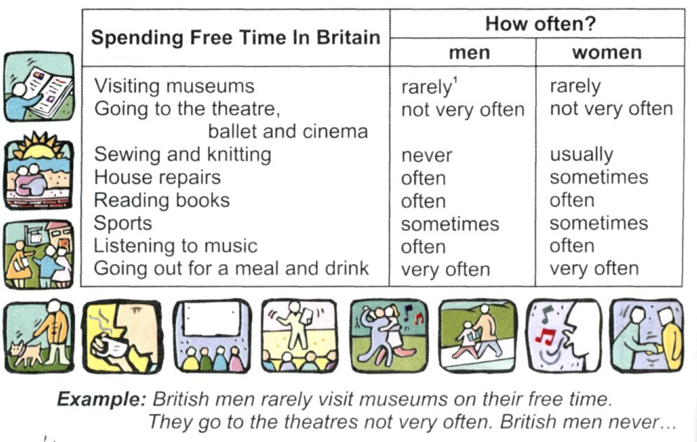

4 клас ( 11.11.2021)

http://meet.google.com/rnz-vqox-ycg – Посилання на відео урок. Початок 8.30.

Тема: Помешкання.
Підтема: Home Sweet Home
Мета уроку:
Навчальна: активізувати навички вживання лексичного матеріалу із теми «Помешкання» та граматичних структур There is\There are; розвивати навички письма, читання та аудіювання;
Розвиваюча: розвивати навички усного мовлення, розвивати мовну здогадку та мовленнєву реакцію;
Виховна: сприяти вихованню взаємодопомоги та дружби під час роботи в групах, інтересу до подальшого вивчення англійської мови.

Обладнання уроку: мультимедійна презентація, флеш-картки із зображенням лексичних одиниць із теми, роздатковий матеріал.

ХІД УРОКУ
1. Привітання. - Good morning! How are you today?
- rhyme “How are you?”
- jazz chants “Checklist”
2. Повідомлення теми та мети уроку. Today we have an unusual lesson. We have a competition. We’ll work in groups. There are special guests: the pupils of the 2nd form (they have got the surprise for you) and the pupils of the 7th form. They will be the jury today and check your tasks. But first try to guess the topic of our lesson. Look at the screen! (pupils guess the topic of the lesson)
3. Уведення в іншомовну атмосферу. Look at the cards and name them.

ІІ. ОСНОВНА ЧАСТИНА УРОКУ
1) So, we’ll join into the groups and the 1st task is to introduce your team. Your hometask was to make a name, motto and the emblem of your team. (3 groups present name, motto and emblem)
2) The next task is the Quiz. Guess the riddles.
You can take a shower or have a bath in this room
You can drink milk and eat sandwich in this room.
You can brush teeth in this room.
You can listen to music in this room.
You can sleep in this room.
You can cook in this room.
You can watch TV in this room.
You can play with your friends in this room.
You can do homework in this room.
You can put on your coat in this room.
You can wash your hands in this room.
You can have a party in this room.

3) The next tasks are lexical. We’ll remember how to write the words:
- the words are without vowels, write down correct words (HO 1)
- match the words with picture (HO 2)
- find nine words and circle them (HO 3)
4) What rooms are traditionally in the flat or in the house? (pupils give their answers) the next task is listening. You’ll listen to the sounds and match the room where you can hear the sounds. (listening)
5) It’s time to relax! Let’s have a music break. The jury will check your tasks and tell us your score!
6) Now we’ll watch a video. Watch the film carefully! Your task is to remember all the furniture and the rooms you see in the film and name them! (watching video)
7) It’s time to check your grammar. But before we’ll do some physical exercises and repeat the prepositions. Game “Catch a fly” (The teacher or a pupil say: The “fly” is on the desk! And rest of the pupils “catch the fly” on the desk. Etc.)
8) Fill in the prepositions. Task on the cards (HO 4)
9) Make up sentences using: always, usually, sometimes, never

III. ЗАКЛЮЧНА ЧАСТИНА УРОКУ
Підведення підсумків уроку.
Let’s sum up the result! The jury will count the points each team has and tell us the score. Now you’ll match the favourite task. Put the smily faces on the board near the task you like most of all.

