11 КЛАС

READING COMPREHENSION

- Read the text below. For (1—7) choose T if the statement is true according to the text, and F if it is false. An example (1) has been done for you.

Road pollution is a serious danger to children’s health. Researchers from the
University of California spent 13 years studying children who lived within 500 metres of busy roads. They found that most of the 3,600 children in the study had weak lungs. Researchers said this meant the children could have breathing problems for the rest of their lives.
The main author of the study W. James Gauderman and his team conducted their research on youngsters who lived near busy roads and in high-pollution areas. Once a year, the team measured the children’s lung power. It checked how much air the children could release in one breath and how quickly it could be released. The team found that by their 18th birthday, children who lived within 500 metres of a highway breezed out three per cent less air compared with children who lived one-and-a-half kilometres away. Further, the highway children’s lung power was seven per cent weaker in the rate at which they could breeze out. Gauderman said that: ≪Even if you are in a relatively low regional pollution area, living near a road produces lung problems≫.
About a third of the children moved away from busy roads during the study
but stayed near the same area. Their lungs developed more healthily.

1) Researchers monitored different children for 30 years.
2) The text doesn’t say how many children in the study had lung problems.
3) Living near a busy road doubles the chances of lung damage.
4) Researchers tested the children’s lungs on a monthly basis.
5) Children living 500 metres from busy roads had 30 % less lung power.
6) Living near a busy road is still bad even if it’s in a low-pollution area.
7) Children who moved away from roads still suffered lung problems.
2. Read the text below. Match choices (A—E) to (1—5). An example (1) has
been done for you.

A) Some of Your Thoughts and Ideas Are Rather Stable and Permanent in Nature
B) Success Is in Your Mind
C) Get in the Habit of Writing
D) Take Time to Think
E) However, There Are Thoughts and Ideas Which Are Usually Temporary
1 ( )
Regardless of your definition of success, most people would agree that success
starts with your thoughts, your ideas and your beliefs — in other words, your
mind. It is a great feeling to realize that with the power.
2 ( )
These are the beliefs, the habits, the behaviour, and all the other details
of the mind that make up the core of who you are. Knowledge, skills and
abilities are other components of your mind that have a somewhat stable
character. So a person’s beliefs, habits, personalities, knowledge, skills and
abilities are important components of success that will not disappear or be
lost in a passing moment.
3 ( )
These are the ideas that pass through your head in a moment of inspiration.
Most people don’t pay much attention to these temporary thoughts when
your mind reveals to you something that could result in a good opportunity.
4 ( )
Successful people understand the importance of spending quality time doing
high-level thinking. You should plan to have a time period of at least 30
minutes to one hour each day when you are alone and your mind is free
from fuss and disorder. Use this time to let your mind flow and reveal to you
the interesting ideas which you may dismiss when you are busy with other
things. When those thoughts come to you, don’t reject them. Let them fill
your mind with the possibilities and with your dreams of success.
5 ( )
You never know when great ideas will pop in your head. Therefore, it is very
important that you always carry with you a notebook and pen to write down
your ideas as soon as they come to you. This notebook can also be very useful
for writing down observations that will help you become successful. If you run
into a successful person that you admire, write down the habits and qualities,
or anything else about this person. If you observe something that is done with
excellence, or high quality, be it a product or a service, write it down.

11 КЛАС
WRITING
- Complete the text with the correct forms of the verbs in brackets.

If you are looking for a new job, here are some job interview tips you should
keep in mind when __________(meet) with a potential employer.
First, try to make a good first ______________(impress). Be sure to dress ____________(suitable) for the situation. For example, if you are interviewed for a job of a_____________ (teacher), then you might want to consider ____________(wear) a nice suit or a dress. However, you don’t want to overdress for the interview either.
Next, be sure to find out about the company for which you are____________
(interview). This will help you know if you have the necessary skills or experience to work for that company. Finding out something about the company will also help you ask intelligent questions about their business to show them you are _______________(interest) in their company. Finally, be prepared to tell them why you would be their best choice for the position. You don’t have to boast about your accomplishments.
However, you can tell them ______________(confident) but_____________
(direct) why you can help their company better
than other applicants.
- Match the words with their definitions.

1) background 4) to go on
2) a variety of 5) experience
3) to tease
A) to make fun or attempt to provoke a person or animal in a playful way.
B) knowledge or skills acquired over a period of time.
C) to carry on with, to continue.
D) the area or scenery behind the main object; or the part of a picture or
design that serves as a setting to the main figures or objects.
E) a number or range of things of the same general class that are different in
character or quality.
11 КЛАС
SPEAKING

- Why is it important to know foreign languages? Discuss the problem in as
many aspects (practical, cultural, educational etc.) as you can.

- Do you agree or disagree with the following statement: it is better to be
a member of a group than to be the leader of a group? Use specific reasons and examples to support your answer.

10 КЛАС

READING COMPREHENSION

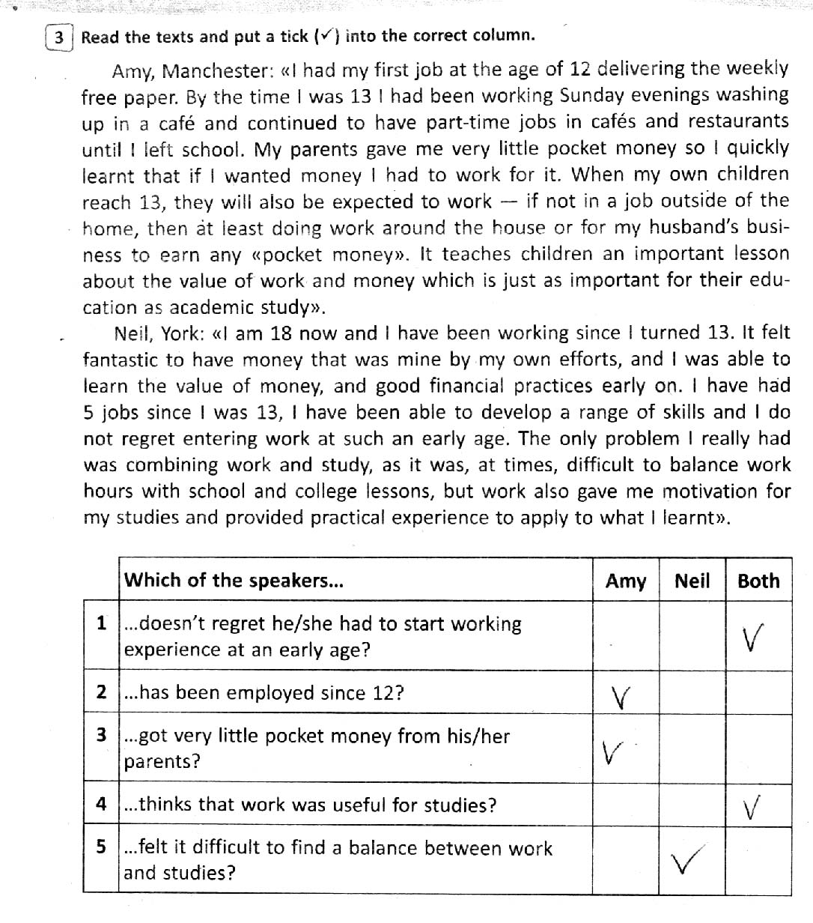

10 КЛАС

WRITING
I. Choose the correct option:
1. My mother…………………………………how to catch my attention.
a) Isn´t know b) doesn´t knew c) doesn´t know d) won´t know
2. It …………………………….you 3 weeks to finish the presentation.
a) Will take b) is taking c) takes d) shall take
3. My sister ……………………………..be at home. She always attends French classes at this time.
a) Mustn´t b) can c) may d) can´t
4. Will you help me with the project? I promise I ……………………………………you with the next one.
a) Am going to help b) shall help c) will help d) would help
5. I ………………………………..my birthday party this Sunday. Everything is ready.
a) Am holding b) will hold c) am going to hold d) hold
6. She ………………………………to the meeting. We really don´t know.
a) Should b) must c) can´t d) may
7. Look at this beautiful statue! I ……………………………a picture right now.
a) Will take b) take c) am going to take d) shall take
8. My father ……………………………….in a factory from 2000 to 2005.
a) Was working b) worked c) will work d) works
9. When Susan called I ……………………………….a nap.
a) Would take b) took c) was taking d) should take
II. Rewrite the sentences in passive voice.
- Kerrie has paid the bill.
- I have eaten a hamburger.
- We have cycled five miles.

10 КЛАС
SPEAKING

- Some people say that the Internet provides people with a lot of valuable information. Others think access to so much information creates problems. Which view do you agree with? Use specific reasons and examples to support your opinion.

2. Tell about three things you can personally do to protect the environment.

9 КЛАС

READING COMPREHENSION

1. Read the text below. For (1—7) choose T if the statement is true according
to the text, and F if it is false. An example (1) has been done for you.

Human-made noise pollution in the Earth’s oceans and seas is becoming a serious threat to sea wildlife. Scientists report that there is hardly an underwater place left where sea mammals can live in peace and quiet. Dozens of species of whales, dolphins, turtles and other creatures depend on sound in their communication, finding mates and hunting for food. So noisy environment is making it difficult to lead a normal life. This is according to a report from the International Fund for Animal Welfare (IFAW), called ≪Ocean Noise: Turn it Down≫. The environmental group says noise from shipping, oil and gas surveys, offshore construction and water sports has reached dangerous levels
for sea life.
The IFAW says the distance over which blue whales can communicate is down by 90 per cent. It also reports that in the past decade, many whales have become beached after being disorientated because of loud noise. The group also warns that noise pollution is only going to get worse. There are 90 survey ships active in the oceans today. In addition, the number of ships sailing the seas will double by 2025. Mark Simmonds, a IFAW spokesman, said, ≪man-made noise is already causing a kind of acoustic fog≫, and called for a ≪response to noise pollution in the underwater≫.

1) The noise humans make is harmful for creatures living in the oceans.
2) There are very few quiet places left in the oceans.
3) Sound doesn’t help sea animals to hunt for food and look for a mate.
4) The distance over which blue whales can communicate has become larger.
5) Noise pollution can mean whales lose their way and die on beaches.
6) The number of ships on the seas is not going to change in the next 20 years.
7) Mark Simmonds, a IFAW spokesman, said it’s very foggy in the oceans.

2. Read the text below. Match choices (A—E) to (1—5). An example (1) has
been done for you.

A) Work Is Honourable
B) Some People Go through Life Hating and Avoiding Work
C) So the Question You Must Ask Is ≪Why Do People Do It?≫
D) Work Gives You a Sense of Purpose
E) Work Is a Means to Develop Character

A week has 168 hours. If you sleep eight hours a day, that leaves 112 hours
per week of active time in your life. If you work about 50 hours a week,
that is almost half of your week’s active time. This is a very significant part
of your life that you spend working.
1 ( )
One simple answer is that most people need to earn money. But many
billionaires, like Bill Gates, Larry Ellison and Warren Buffett, spend a significant
amount of their time working, probably more than most people. And yet, they
don’t need any money. Let’s look at the advantages work can give us.
2 ( )
Many people go through their working life thinking about retirement. They
think about the day when they will just be able to sit back, relax and take it
easy. But when the day arrives they enjoy the first few months of their newly
found freedom and stress-free living, but after a while they start losing their
sense of purpose. Their work gave them a sense of being important that they
now miss, and they start to feel worthless.
3 ( )
In many lines of work, you have to deal with people and their personalities,
egos, beliefs, cultures, politics, habits, and all of the struggles and joys that
make up the human existence. You also face conflicts and hard choices. As
you gain experience in your work, you develop character. You learn how to
deal with different types of people and different situations.
4 ( )
When you do a good job, you feel a sense of pride and achievement. Being
able to work in whatever capacity, is an honourable activity.
5 ( )
But I haven’t seen a successful person yet that does not do any type of
work. Work is the very essence of what success is about.

9 КЛАС
WRITING
1. Read the description of professions. Choose and circle the letter of the
correct answer. An example (1) has been done for you.

1) A person who arranges travel plans for clients.
A) travel agent B) receptionist C) estate agent
2) A person who designs buildings.
A) accountant B) designer C) architect
3) A person who takes care of patients.
A) surgeon B) physicist C) nurse
4) A person who prepares food.
A) lawyer B) chef C) carpenter
5) A person who writes software programs that are used on computers.
A) machine operator B) programmer C) editor
6) A person who cuts and styles hair.
A) hairdresser B) haircutter C) hairstyle
2. Complete the sentences with the letters of the correct variant.

1) Documentaries help me to broaden my on different historical events and problems.
A) outlook B) broadcast C) worldwide
2) Television and the Internet are prime of information for teenagers.
A) programmes B) resources C) sources
3) The floor organizes the work of the studio floor following the instructions of the director of the programme.
A) presenter B) manager C) operator
4) About 40 per cent of teenagers have or satellite TV at home.
A) cable B) commercials C) vision
5) This reality attracted a large audience.
A) programme B) advertisement C) show.

9 КЛАС
SPEAKING

- Some people say that computers have made life easier and more convenient.
Other people say that computers have made life more complex and stressful.
What is your opinion? Use specific reasons and examples to support your answer.

2. People listen to music for different reasons and at different times. Why is music important to many people? Use specific reasons and examples to support your opinion.

8 КЛАС

READING COMPREHENSION
1. Read the text. Choose the best answer and mark the letter or symbol of your choice.
Jenny lived on Hamilton Street. It was a long line of wooden houses with children playing in front of them, and whole families sitting on their front steps. I felt like a stranger in a strange land as I parked the MG outside 189A Hamilton Street. Mr. Cavilleri's hand shake was warm and strong. "How do you do, sir?" I said. "I'm Phil," he said. "Phil, sir." It was a frightening moment. Then Mr. Cavilleri turned to his daughter. Suddenly they were in each other's arms, laughing and crying and kissing. I felt like a stranger. For some time I did not have to speak much. "Don't speak with your mouth full," my family had told me when I was a child. Phil and his daughter kept my mouth full all afternoon. I don't know how many Italian cakes I ate. Both Cavilleris were very pleased.
1. The houses on Hamilton Street were made of:
A. glass B. brick C. wood D. steel
2. The narrator of the passage and Jenny came to 189A Hamilton Street by:
A. boat B. car C. plane D. train
3. Phil was Jenny's:
A. father B. brother C. grandfather D. uncle
4. At the table the narrator of the passage:
A. spoke much B. ate much C. laughed much D. cried much
5. The Cavilleris were:
A. very glad B. very sad C. very unhappy D. very unpleased

2. Put "+" next to the true sentences and "—" next to the false ones.

1. Cavilleris live on Hamilton Street.
2. The narrator of the passage and Jenny came to Jenny’s parents.
3. Mr. Cavilleri was very glad to see his son.
4. Mr. Cavilleri’s name was Jim.
5. Cavilleris were Italian.

8 КЛАС
WRITING
1. Choose the correct answer.
1. This is a large hall. Many parties ..... here.
are held
are being held
has been held

2. Not much ..... about the accident since that time.
has said
said
has been said

3. In more than 200 years the USA Constitution ..... 26 times.
is amended
is being amended
has been amended

4. I don't think we must ..... everything tomorrow.
finish
have finished
be finished

5. Two men tried to sell a painting that ......
was stolen
had been stolen
had stolen

6. The bridge ..... by tomorrow morning.
will have been reconstructed
is being reconstructed
will be reconstructed

- Match the sentences with the tenses.

1) He goes in for wrestling. a) Past Simple
2) They visited some museums. b) Past C ontinuous
3) I have made some photos. c) Future Simple
4) We are discussing this idea. d) Present Simple
5) She will join us. e) Present Perfect Continuous
6) They have been working all day. f) Present C ontinuous
7) You were waiting at the bus stop. g) Past Perfect
8) He had returned before supper. h) Present Perfect

8 КЛАС
SPEAKING

Some TV programmes are serious, designed to make the audience think.
Other programmes are designed primarily to amuse and entertain. Which type of programme do you prefer? Use specific reasons and examples to support your answer.

7 КЛАС

READING COMPREHENSION

- Read the text and choose the correct answer.

Four__________(1) stood smiling behind the Ukrainian flag, celebrating their
country's first gold__________(2) at 2014 Sochi Olympics.
The Ukrainian women biathlon team provided some good news with their
__________(3) — Ukraine's first Winter Olympics gold medal in two decades.
Twins Vita and Valya Semerenko combined with Yuliya Dzhyma and Olena Pidhrushna won the last women's biathlon competition in Sochi. There were tears, and then there were smiles. It was the second medal for Ukraine at these__________(4), after Vita Semerenko took bronze in the women's 7.5 km sprint.
A |  | B |  | C |  | D
1 | teammates |  | classmates |  | friends |  | sisters
2 | race |  | sportsman |  | medal |  | rings
3 | victory |  | contest |  | achieve |  | winner
4 | event |  | games |  | match |  | week

- Read the text and complete the questions with the correct question words.

The Guard that looks after Buckingham Palace is called The Queen's Guard. All the guards taking part in the ceremony are dressed in traditional red tunics and bearskin hats. Changing the Guard also takes place at Windsor Castle and at Horse Guards Arch on Horse Guards Parade. Changing the Guard does not take place on the forecourt of Buckingham Palace in very wet weather. Any decision to cancel Changing the Guard at Buckingham Palace, due to wet weather, is made by the Captain of the Guard at the last minute.

1) ___________________________is the Guard that looks after Buckingham
Palace called?
2) _________________________are all the guards taking part in the ceremony dressed?

3)___________________does Changing the Guard not take place on the forecourt of Buckingham Palace?

4)______________makes a decision to cancel Changing the Guard because of wet weather?

7 КЛАС
WRITING
- Read and circle the correct variant.

1) It rained/was raining, so I took/was taking an umbrella with me.
2) Jan was having/had breakfast when the phone was rainging/rang.
3) What was the weather like yesterday? — The sun shone/was shining all day.
4) My mother cooked/was cooking dinner when I got home yesterday.
5) I am/was riding my bike when a dog appeared/was appearing in front of me.
6) Caroline was studying/studied for 2 hours yesterday.
2. Choose and circle the correct modal verb.

1) — Can / May you play the guitar well?
2) There's a bus to Oxford Street, so we needn't / mustn't walk.
3) — May / Must I go out, mummy?
— No, you can't / needn't, you may / must do your homework first.
4) The doctor says I must / may stay in bed till my temperature goes down.

7 КЛАС
SPEAKING

Tell your friend about the members of your family and one of your family traditions.
Ask your friend what he/she thinks about the importance of keeping family traditions.

6 КЛАС
READING COMPREHENSION
1 Read and complete the text. There are two choices you don’t need to use.

a) it becomes more difficult to learn new languages
b) the sounds of another language
c) learning a second language
d) when they speak it
e) you have to memorize
f) as well as their native language

Young children can learn a new language very easily. If they are surrounded by people speaking a different language, they soon learn to speak it_______ (1). Children who mastered two languages in this way are called simultaneous bilinguals though even in this case one language can be considered as the main one dominating over the other. But as people grow older, __________(2). People gradually lose the ability to learn the grammar and pronounce ___________(3). People who learn a new language as adults often have a «foreign accent» ____________(4).

- Read the text and mark the following statements as «True» or «False».

One of the widespread myths about travelling is that trains are the cheapest way to take a trip across Europe — eventually this is not true. To prove that we have conducted a short investigation.
Train tickets are becoming more and more expensive every year. A standard ticket from Frankfurt to Rome costs a minimum of $350, and the price depends on what time and day you are travelling.
The recent deregulation of air transport in Europe made it possible for such ideas as low-cost airlines and increase in European destinations to come true.
Low-cost airlines appeared on the market with a new business model different from the traditional ones. So flights are so cheap now you can fly from Frankfurt to Rome for just $90, and you don’t have to worry about food or drink as the trip just takes a few hours. Travelling the same distance by train takes over 12 hours, and although it can be more relaxing you will need to consider additional accommodation and dining cost if you are travelling overnight.

1) According to the text, trains are the cheapest way of travelling across Europe.—
2) Nowadays train tickets are as expensive as they were several years ago.—
3) Travelling by plane may be cheaper than travelling by train.—
4) Travelling by train will take you longer, but it is usually more comfortable compared to flying.—

6 КЛАС

WRITING
- Make up sentences.

1) as /as / happy / child / I’m / a /.
2) you / again / a bit louder / say / can / it / ?
3) he / English / speak / speaks / fluently / Ukrainian / does / as / as / he / ?
4) big / is / Belgium / as / France / not / so /.
5) just / met / they / have / ?
6) had / for / ticket / a / one-way / enough / they / cash /.
6 КЛАС
SPEAKING

Speak about your attitude to sport. Answer the questions.

1) What is your favourite team sport?
2) What is your favourite summer/winter sport?
3) What new sports would you like to try?
4) What is the most popular sport in your country?
4 КЛАС

READING COMPREHENSION

Read the text about Mary.
Mary is ten. She is very clever. She is good pupil. She is the best in her class. Mary likes books and reading. Her favourite subject is English. She can write good stories. Mary doesn’t like sport, but she likes animals. She’s got a little cat. It’s called Puffy. Mary is good at acting, too. She is in a drama group at school.
Complete the questions.
1. How old ______ Mary?
- Is _______clever?
- _______she the best pupil in her class?
- What’s ______ favourite subject?
- Can she ______ good stories?
- ______ she got a dog or a cat?

4 КЛАС
WRITING
- Fill in is, are, was, were.
1) Mandy _____in Lviv last summer.
2) Steve and Andy ______in the village now.
3) Carl _______at the supermarket now.
4) Mrs Newton ________ not at the bank at the moment.

- Write the words in brackets into the correct tense.

- Ben’s father is watching (to watch) TV now.
- She ____________________________________ (to ride) a bike now.
- I usually_______________________________ (to read) books in the evening.
- Ben’s mother ____________________________ (to clean) the house now.

4 КЛАС
LISTENING COMPREHENSION

Listen to the text. Choose T if the statement is true according to
the text, and F if it is false.

1. Vicky’s grandpa is going to visit them next weekend.
2. Grandpa is going to come by taxi.
3. Vicky and her mum are going to meet grandpa at 3 o’clock.
4. They are looking for the information desk.
5. The train arrives at 4:15.
6. It arrives at platform 3.

4 КЛАС
SPEAKING

Tell about your room and what you can do there.

3 КЛАС

READING COMPREHENSION

Arrange the sentences in the logical order to make up a dialogue.

- Hello. This is Helen speaking.
Goodbye!
Well. My birthday is on Sunday. Can you come?
Of course.
Hi, Helen! It’s Kate. How are you?
Great. See you on Sunday, then. Bye!

3 КЛАС
WRITING

Order and write the sentences.
1. has / Jane / a / got / party / .
2. Friday / afternoon / on / The / party / is / .
3. invitations / her / Jane / sends / the / for / friends / .
4. presents / She / to / open / the / likes / .
5. the / morning / Jane / cleans / usually / the / house / in / .

3 КЛАС
LISTENING COMPREHENSION

Listen to the text. Choose T if the statement is true according to
the text, and F if it is false.
1. Nick invited his friends to come at 3 p.m. to his birthday party.
2. His friends made a birthday cake for him.
3. Bill bought some butter and eggs on the shop.
4. Vicky brought some jam.
5. Vicky brought some flour.
3 КЛАС
SPEAKING

Look at the form and speak about Tony.

Look! This is Tony. He is...

Name Tony
Age 9
Country Spain
City Madrid

Family father — driver,
mother — secretary,
brother — schoolboy

Favourite lesson Maths
Hobby swimming

