25.05
3 клас
Тема: Контрольна робота з читання та говоріння.

ЧИТАННЯ
Test

Part A: Read (Прочитай)

This is May. She’s ten years old. She’s tall and thin. She’s got long brown hair. She’s got brown eyes. She can sing and dance. She can’t swim.
Every Monday, May reads Chinese books with her friends. Every Tuesday, she rides a bike to school. On Wednesdays, she plays music at school. On Thursdays, she sings English songs with her friends. Every Friday, she cooks eggs at home.

Part B: Write the day please (Під картинкою підпиши день, в який Мей займається цим…)
 | 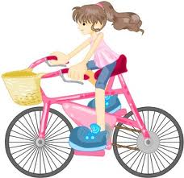 |  | 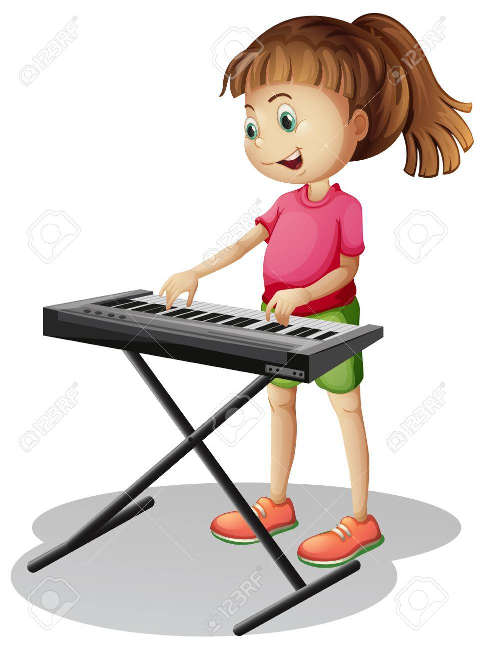 | 
__________ | __________ | __________ | __________ | __________

Part C: True or False (Так чи ні)

1. May reads Chinese books. _________

2. May rides a bike to school on Fridays. _________

3. She plays music at home. _________

4. She plays music at school on Wednesdays. _________

5. She cooks pizza. _________
Part D: Please answer Yes or No (Дати короткі відповіді на питання)

1. Does May ride a bike on Mondays? ______ , _______ ________.

2. Does May sing English songs? ______ , _______ ________.

3. Does May cook on Fridays? ______ , _______ ________.

4. Does she play music on Wednesdays? ______ , _______ ________.

5. Does May read Chinese books on Tuesdays? ______ , _______ ________.

ГОВОРІННЯ
Переказати текст 5-6 речень.
Записати відеопереказ та вислати на вайбер.

